Development and Optimization of a BERT-Based Semantic Similarity System for Automated Summary Evaluation in Support of SDG 4

Alexis Laniosa
College of Computer Studies and Engineering
José Rizal University
Mandaluyong City, Philippines
alexis.laniosa@my.jru.edu
Charles Aaron Sarmiento
College of Computer Studies and Engineering
José Rizal University
Mandaluyong City, Philippines
charlesaaron.sarmiento@my.jru.edu

Laurence Baste
College of Computer Studies and Engineering
José Rizal University
Mandaluyong City, Philippines
laurence.baste@my.jru.edu

Abstract—This study presents the development and evaluation of an AI-powered summary assessment tool that leverages transformer-based models—specifically BERT and Sentence-BERT—to measure the semantic similarity between academic source texts and student-generated summaries. The system is designed to enhance learning efficiency by providing immediate, meaningful feedback aligned with the principles of formative assessment. Using the SciTLDR dataset and additional evaluation data, the study fine-tunes a MiniLM-based sentence embedding model through extensive hyperparameter optimization using Optuna. Correlation-based metrics (Spearman and Pearson) are used to quantify alignment between model outputs and human-judged similarity. Results show that configurations involving MEAN pooling, moderate learning rates, adaptive optimizers, and controlled dropout produce the most robust performance, with peak Spearman correlations near 0.857. A prototype summary-evaluation interface demonstrates the practical educational application of the system. This work highlights the potential of transformer-based NLP models to support equitable and scalable feedback mechanisms in higher education, contributing to Sustainable Development Goal 4: Quality Education.
Keywords— BERT, Natural Language Processing (NLP), AI in Education, Text Summarization, Study Reviewer Generation, SDG 4

I. Introduction

Background and Context
Education is undergoing a professional transition, one in which data-driven technology is changing how students can learn, how educators can teach (including assessment), and how institutions can make decisions. With the rapid expansion of online and blended learning, a growing number of students are learning through digital mediums, completing assessments online, and engaging with educational platforms and tools (e.g., LMS) that produce massive amounts of educational data every day. By analyzing this educational data, educators can observe trends in student performance, learning behaviors, and levels of engagement and can identify areas in which students might be struggling in their learning and provide educators the opportunity to support those students quickly and in the learning process, and to personalize instruction to improve learning outcomes.
At the same time, new capabilities in Artificial Intelligence (AI) and Natural Language Processing (NLP) have enabled systems to analyze educational products (e.g., essays, discussion posts, self- or peer-provided observational feedback) automatically and accurately. Many of these advances rely upon transformer-based language models such as BERT, which shows the ability to produce accurate semantic understanding and context interpretations about human language [4]. These transformer models can do more than recognize particular keywords; they can analyze the extent to which two discovered pieces of text accurately convey the same meaning. This ability to assess the relationship between texts is particularly useful for educational applications in which student writing must be interpreted.
A central focus in this area is semantic sentence similarity—determining the extent to which two sentences or passages convey similar meanings. This task is important for applications such as automated essay scoring, summary evaluation, question answering, and plagiarism detection, because it needs to go beyond word surface matching and more deeply assess for semantic alignment. Fine-tuning a pre-trained BERT-based model on datasets that specifically look for semantic similarity allows it to be adjusted to educational contexts where student products need to be compared against a source.

Significance of the Study
The proposed system enhances AI-powered instructional technology by giving students instantaneous, systematic feedback on how well the meanings of their summaries reflect the meanings of the source material. Instead of relying on self-evaluative judgments or waiting for feedback from the instructor or other evaluators, students can now directly assess how well their summaries convey the main ideas of the source texts. This type of experience enables students to create an active learning experience that is both engaging and focused on reflective practice and metacognitive awareness as they work to improve their summaries via their own feedback.
For instructors and institutions, the proposed system provides a scalable way to assess students' comprehension of course material. Using a scaler that generates aggregate summaries for students and by examining any patterns in summary similarity scores gives instructors a foundation to identify which topics students struggled with as they move forward in a course. While it may not serve as a replacement for instructor assessment, similar systems help reduce the workload of assessing and evaluating pieces of written work, especially in large class environments.
More generally, this work demonstrates a method relevant to the Sustainable Development Goal 4 (SDG 4) of Quality Education by showing how a BERT-based natural language processing (NLP) model can be successfully fine-tuned for deployment and developed to support fair and equitable tech-enhanced learning experiences [8]. Additionally, by addressing semantic similarity for summary writing during a focus on student generated summaries, this work highlights both the technical work of hyperparameter tuning, as well as the pedagogical significance of AI-assisted formative assessment.

II. Problem Statement

A. Domain: Education
Education continues to serve as a foundational force for an individual’s development and a given society's advancement; however, students still struggle to process and internalize the information they read in academic materials in a timely and effective way. In many college classes, for example, a student is assigned to read twenty pages from a textbook, several articles, notes from lectures, etc., and then the student is evaluated on their understanding through written summarization and/or reflection. While summarization is an effective method for processing and evaluating comprehension while engaging in critical thinking, students often experience trouble gauging whether their summaries accurately reflect the author's main points and details.
Current learning environments are often limited in offering automated feedback and support for formative assessment of this nature. Systems known as learning management systems (LMS) typically only provide pertinent information regarding a student’s learning experiences related to quiz scores, assignments completed, and overall grades, but they do not provide information that measures the degree to which a student’s written assignment (the summary in this context) accurately reflects the main ideas in the text and the content of the material. Therefore, a student could continue studying content in such classes with their misunderstandings and students who display an incomplete understanding of the study material also escape detection by instructors in large classes where it is not feasible to process every written assignment individually.

B. Societal Problem: Learning Inefficiency
Conventional study methods rely primarily on students reading, highlighting, and summarizing information on their own without timely and intentional feedback on their writing. This can lead to many issues: (1) students could write summaries that either do not include key ideas or overly include trivial details; (2) students may have difficulty assessing whether summarized content was semantically accurate to the original document; and (3) instructors may not have the time and ability to provide rigorous feedback on each student summary. Collectively, these issues can create ineffective learning, ongoing misconceptions, and inequitable opportunities for quality feedback - this is contrary to the ideals of (SDG 4): Quality Education Development Goal 4: Quality Education, which encourages inclusive, equitable, and working quality educational opportunities for all. [8]

While recently developed Artificial Intelligence (AI) and Natural Processing (NLP) capabilities have led to strong transformer models (e.g. BERT, Sentence-BERT) to measure semantic similarity between texts, many educational contexts still lack technology that benefits from summaries enhancing educational engagement. Existing automated writing products rarely assess grammar, style, and even plagiarism, but do not assess assessment opportunities of semantic alignment to students' summaries.

This creates a disconnect in practice and research: a lack of an AI-enabled system capable of comparing student-generated summaries to the source documents while also providing useful, semantically relevant feedback about their accuracy and relevance. Additionally, to maximize and ensure both reliability and pedagogical usefulness via a BERT-based model, thorough fine-tuning and experimentation with critical hyperparameters will be necessary. Bridging this gap can lead to enhanced learning efficiencies, further equitable feedback, and better comprehension in the higher education context.

III. Research Objectives

A. General Objective
To develop and evaluate an AI-powered summary evaluation system that uses a fine-tuned BERT-based semantic similarity model to assess the relevance and accuracy of student-generated summaries with respect to academic materials, in support of Sustainable Development Goal 4 (SDG 4): Quality Education. [8]

B. Specific Objectives
- To develop and deploy a natural language processing (NLP) pipeline to extract and represent the context of academic texts and to compare the context to summaries created by the student body using semantic similarity measures.

- To fine-tune and optimize a BERT or Sentence-BERT model for semantic sentence similarity used in educational settings by taking a systematic approach to experiment with multiple hyperparameters including learning rate, optimizer type, scheduler, batch size, number of epochs, gradient accumulation steps, pooling strategy, dropout rate, and embedding size, and then assess the adjusted model performance for accuracy and compute efficiency using correlation based metrics.

- To integrate the adjusted semantic sentence similarity model into a summary evaluation prototype and conduct an initial user-centered evaluation with undergraduate students examining clarity and usefulness of feedback generated by the evaluation, which could serve to improve the equitable learning process aligned with SDG 4.

IV. Review of Related Literature

- Importance of Hyperparameter Tuning in Transformer Models
Hyperparameter tuning is a vital process in improving the accuracy and stability of transformer-based models such as BERT. Mosbach et al. [15] emphasized that fine-tuning hyperparameters like batch size, learning rate, and epochs can significantly affect model generalization and convergence behavior. Improper tuning may lead to overfitting, gradient instability, or poor semantic representation. By systematically adjusting these parameters, researchers can identify the optimal configuration that balances both performance and efficiency for a given dataset or task.
2. Effects of Sequence Length, Warmup Ratio, and Computational Efficiency
The maximum sequence length and warmup ratio are key parameters that influence the computational and representational efficiency of BERT models. Beltagy et al. [17] found that longer sequence lengths improve contextual understanding but require greater computational resources. Popel and Bojar [16] further highlighted that adjusting the warmup ratio helps stabilize training during the early stages, especially when using small datasets.
In addition, training time has become a practical metric for assessing model efficiency. GPU-accelerated hardware, such as the NVIDIA Tesla T4, has been shown to significantly reduce fine-tuning time compared to CPU-based training [19]. The use of GPUs enables faster forward and backward propagation, allowing for larger batch sizes and longer sequences without major time penalties. Thus, measuring training duration alongside accuracy metrics provides a more comprehensive evaluation of model performance and efficiency.
3. Evaluation Metrics for Semantic Similarity
To assess model performance beyond training loss, semantic correlation metrics are often used. Reimers and Gurevych [7] demonstrated that Spearman and Pearson correlation coefficients are reliable measures of semantic alignment between sentence embeddings and human judgments. A higher correlation score indicates that the model captures the intended meaning between text pairs more effectively. Spearman focuses on ranking relationships, while Pearson evaluates linear associations [20]. Together, they provide a balanced view of model accuracy in representing semantic similarities

V. Scope of Work
This project realizes an AI-driven summary evaluation tool, leveraging a fine-tuned transformer-based sentence similarity model, to compare summaries generated by students against the initial source of academic material. The realization was conducted in a Google Colab notebook and included the following: 1) dataset preparation; 2) model training and hyperparameter tuning using Optuna; 3) saving the best model; and 4) developing a user-friendly summary evaluation web application. The overarching goal is to provide automated feedback grounded in semantics that promotes more effective learning, in support of SDG 4: Quality Education.

A. Data Collection and Preprocessing
The project uses two types of text data:
1. Training and validation data for semantic similarity:
- The notebook loads the Blaise-g/scitldr dataset from the Hugging Face Hub, which contains scientific articles and their corresponding TL;DR-style summaries.
- From the train split, pairs of (source text, summary) are extracted and normalized. These become positive pairs (high similarity).
- Additional negative pairs are constructed by mismatching sources and summaries (e.g., pairing a source with a summary from a different document).
- The data is shuffled and split into training and validation sets.
2. External evaluation data:
- A separate CSV file (test.csv) is loaded as a test set, containing columns sentence_A, sentence_B, and label.
- This dataset is used to compute semantic similarity performance (Spearman and Pearson correlation) on text pairs that are independent from the training data.
Preprocessing steps implemented in the notebook include:
- Converting raw entries to normalized strings (via normalize_text),
- Building InputExample objects for training,
- Structuring positive and negative pairs for binary similarity labels (1.0 for similar, 0.0 for dissimilar),
- Creating ready-to-use lists for train, validation, and test splits.

B. Model Selection and Semantic Similarity Development
In this phase of the project, a transformer-based architecture, such as BERT or Sentence-BERT, is implemented as the primary model for semantic similarity. Each of these models was selected in large part due to their ability to produce contextualized embeddings which capture the meaning of the sentence as opposed to capturing just the meaning of individual words. The BERT model is adapted so that both the source context and the student summary are encoded to be represented as vector representations and a similarity function like cosine similarity is subsequently used to score how semantically similar the two pieces of text are to each other.

The main tasks in this phase involve loading an appropriate pre-trained BERT-based model, selecting and configuring an appropriate pooling strategy for obtaining sentence-level embeddings, and preparing the model to fine-tune on educational data or data related to semantic similarity. The main deliverable from this task is a semantic similarity model that can output meaningful scores that reflect how similar the reference text and the student written summary are to one another.

C. Summary Evaluation System
Using a semantic similarity model, the project creates a summary evaluative system that aligns with the teaching and learning process. The summary evaluative system begins when a knower's academic document is inputted into the system, which extracts relevant context. The knower then writes their own summary of the context. Both the original context and the knower's summary are fed into the fine-tuned BERT-based model, which returns a similarity score that illustrates the alignment of the knower's summary to the content and intention of the original context.
The system is programmed to provide and also communicate the score as a level of meaning that can be pedagogically relevant. For example, a similarity score might be fine-tuned to be a low, moderate or high relevance or include specific prompts like add more key ideas or revise wording. This aligns with active learning since the knower must first write their own summary, while they then draw on the tool for feedback for reflection and revision.

D. User Interface Development and Integration
In order to facilitate practical use of the summary evaluation system, a straightforward prototype interface is developed for use on a browser or notebook environment. The interface allows users to either upload or select a document, view the extracted context, and then fill in their own summary in the text box following submission. Following submission by the student, the interface sends the context and summary to the model, and then displays a similarity score and any feedback.
It should be noted that this interface is not intended to be a fully deployed product, but a functional prototype. The goal is to facilitate the entire process of selecting a document, writing a summary, and allowing for automated evaluation. This prototype may evolve into a broader and potentially integrated experience with inputs from learning management systems or other education platforms, but those activities are not included in the scope of this study.

E. Hyperparameter Optimization and Experimental Setup
An essential component of the work is optimizing model hyperparameters to increase semantic similarity performance and stability. The constituent of the project systematically experiments with different hyperparameters, specifically learning rate, optimizer type, learning-rate scheduler, batch size, number of epochs, number of gradient accumulation steps, pooling strategy, dropout rate, and embedding-related hyperparameters
These experiments are performed in a GPU-facilitated environment to reduce run-time and allow for moderately-sized batch sizes and sequence lengths. For each hyperparameter configuration, the model is fine-tuned on the training data and then, any evaluation occurs on a validation or test set, which employs various correlation-based metrics to quantify every evaluation. Ultimately, training time is also recorded, as it provides information on the trade-off between performance, robustness, stability, and computational expense; the full comparison made with regards to computational expense enables one to identify an optimal hyperparameter configuration that provides reasonable accuracy, robustness, and overall efficiency for educational use.

F. Testing and Evaluation
The final aspect of the scope is to test and evaluate the model and the prototype system. The model is evaluated at the model level by applying the semantic similarity metrics of Spearman and Pearson correlation coefficients between the similarity scores from the model and the labels or reference scores provided by humans. The coefficients inform researcher whether the similarities from the model align with similarities of human subjects.

A prototype systems is evaluated at the system level by exercising the prototype with sample academic texts and example student summaries to determine whether the scores behave as expected for stronger and weaker summaries. While the research cannot conduct a full user study as part of the immediate scope of this project, the prototype system demonstrates practical model application towards automated feedback processes. The evaluation process informs future work with real students and real teachers, broader usability testing, and further exploration of the system’s potential to contribute to SDG 4 through accessibility and related-potiential high quality, feedback about student understanding.

VI. Methodology

A. Tools and Development Environment
The implementation was executed in Google Colab with the utilization of Python, PyTorch, and the Sentence-Transformers library for transformer-based sentence embeddings. We used a GPU runtime (e.g., NVIDIA Tesla T4) for the environment that significantly reduced training time and allowed us to experiment with several hyperparameter configurations. Furthermore, we relied on libraries such as Optuna for hyperparameter optimization, Hugging Face Datasets for loading datasets, and pandas and NumPy for data hosting and handling, and textract for extracting text from uploaded documents. We also leveraged ipywidgets and google.colab utilities to create a simple interactive interface for summary evaluation within the notebook environment.
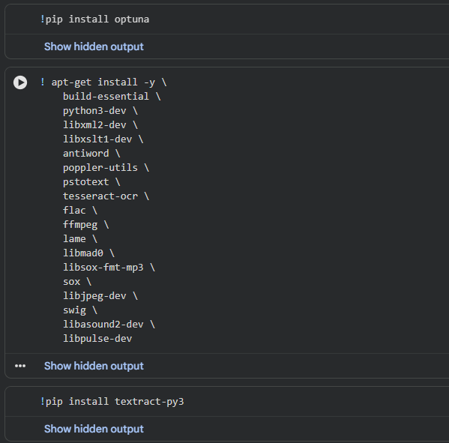Figure 1. Library and dependency setup in Colab

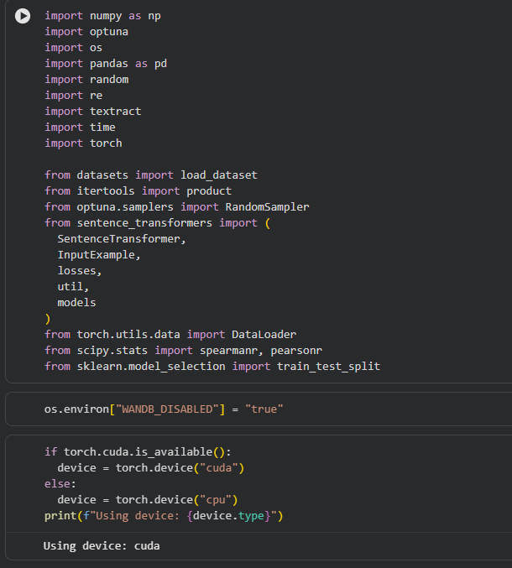
Figure 2. Imports and GPU configuration

B. Dataset Preparation
This study relied on two types of data. The primary training and validation data for semantic similarity came from the Blaise-g/scitldr setup on the Hugging Face Hub, which consists of articles with summaries written by humans in TL;DR style. From this dataset's training split, we extracted the articles' texts and their matching summaries, and these were normalized as plain texts. The pairs of original articles and summaries were treated as positive examples of semantically similar sentence pairs.
To train the model to classify pairs as either similar or dissimilar, negative examples were generated by mismatching articles and summaries on purpose. For example, an article's source text may be mismatched with a summary from a different article's text, which was then rated as low similarity. A combination of positive examples against the negative examples produced a balanced data set of training instances with binary labels (1.0 for similarity, 0.0 for dissimilarity).
We also used a CSV file (test.csv) with sentence pairs and similarity labels for an external evaluation system. test.csv provided three columns (sentence_A, sentence_B, label), and was processed through the Datasets library as separate "eval" split. We computed semantic similarity metrics (Spearman and Pearsons correlation), and evaluated the generalization performance of the model beyond the SciTLDR training data.
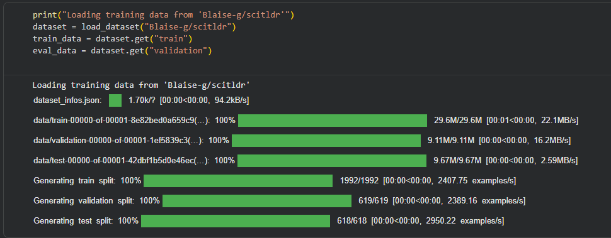Figure 3. Loading the SciTLDR dataset
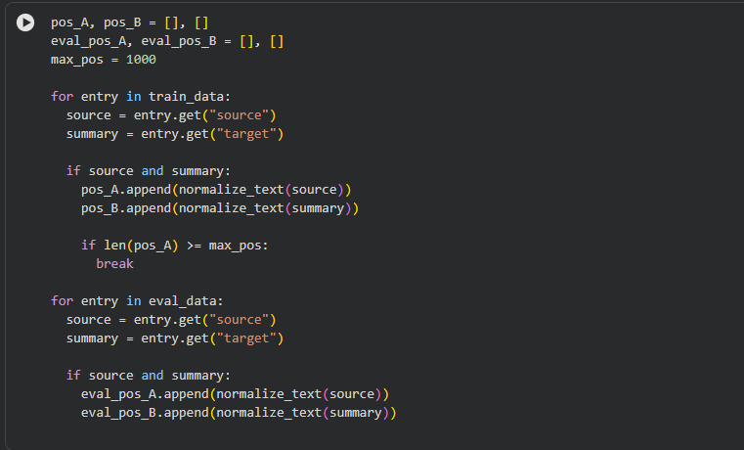
Figure 4. Building positive source–summary pairs
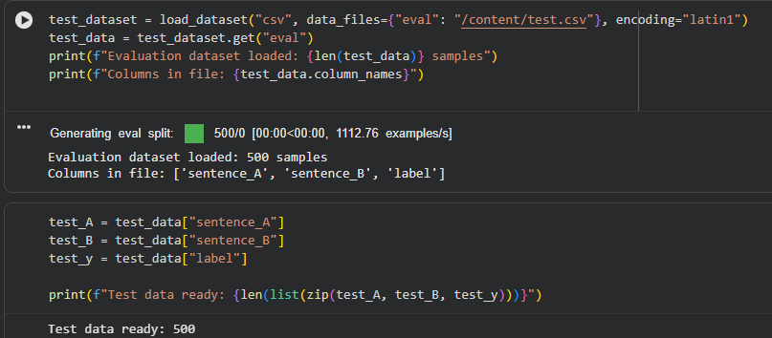Figure 5. Loading the CSV evaluation dataset

C. Model Architecture
The base model used in this project was sentence-transformers/all-MiniLM-L6-v2, a small transformer model designed for efficient sentence embedding. A build_model function was created in the notebook to create the architecture. The function loads the MiniLM transformer, applies a configurable dropout rate to the attention and hidden layers if desired, and then adds a pooling layer that turns the token embeddings into a single sentence embedding at the end (e.g., mean pooling).

The overall architecture is then encapsulated as a SentenceTransformer object, which has a consistent interface for encoding sentences as well as training with sentence-pair objectives. This interface is helpful because both the source context and the student's summary can be converted into dense vector embeddings that represent their semantic meaning. Similarlity between the two texts is then computed later using cosine similarity on the embeddings.

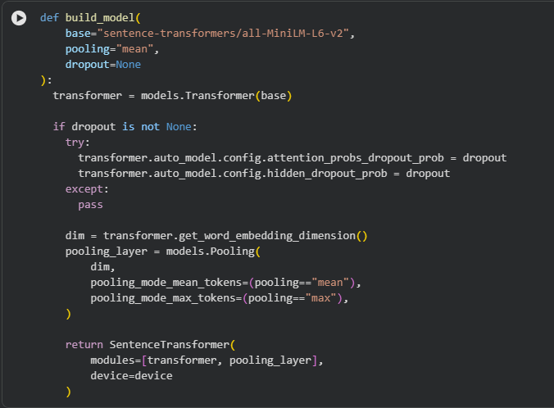Figure 6. build_model function for the MiniLM-based encoder

D. Training Procedure
The training and evaluation process was captured in a train_eval method. Each run passes a model instance, training instances, hyperparameters, and the external test set, to the function. The training instances are converted to InputExample objects so that each has a pair of texts and a similarity label for the pair.
The model is trained using the CosineSimilarityLoss class that is part of the Sentence-Transformers framework. This loss encourages the embeddings of similar pairs to be clustered together, and dissimilar pairs to be separated in cosine similarity space. A training dataloader is created with batch size specified as a hyper-parameter, and the number of warmup steps in the learning-rate schedule is calculated as the proportion of steps (based on the ratio of warmup steps).
During training, evaluation is completed at intervals, using the external test set. During evaluation, each sentence in the test pair is converted to an embedding using the current model, the cosine similarity for the embeddings is computed, and the scores are compared to the ground truth label. Spearman and Pearson correlation coefficients are calculated as a statistical measure of the agreement of the similarity score with human label similarity scores. Training time is saved to analyze computational efficiency.
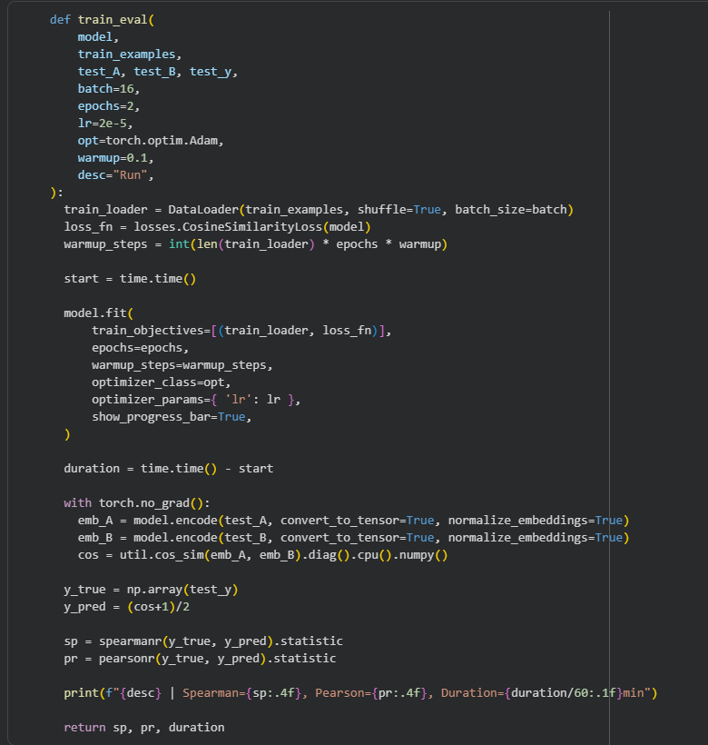
Figure 7. train_eval training and evaluation routine

E. Hyperparameter Optimization with Optuna
To investigate the effect of selected hyperparameters on model performance systematically, we employed Optuna to automate hyperparameter optimization. Optuna requires an objective(trial) function where we define the search space and decision for each trial in the optimization process. In the objective function, Optuna samples the values of the hyperparameters of interest (e.g. batch size, learning rate (on a log scale), dropout ratio, and warmup ratio).
For each trial, the sampled hyperparameter values are passed to the build_model function, which builds the model with the provided configurations. The train_eval function is then executed to fine-tune that new model and evaluate the performance on the test set. For our work, we return both the Spearman correlation coefficient between the model output similarity scores and the ground truth label values as the objective to be maximized. Pearson correlation and training time are also recorded for analysis, but are not optimizations goals.
The random sampler, in Optuna, then explores the hyperparameter space across multiple trials storing the results for each configuration. Once all trials have completed, the study returns the hyperparameter configurations that yielded the highest Spearman correlation. The final training configuration is formed from these best hyperparameters (i.e. optimal learning rate, batch size, dropout ratio, and warmup ratio).
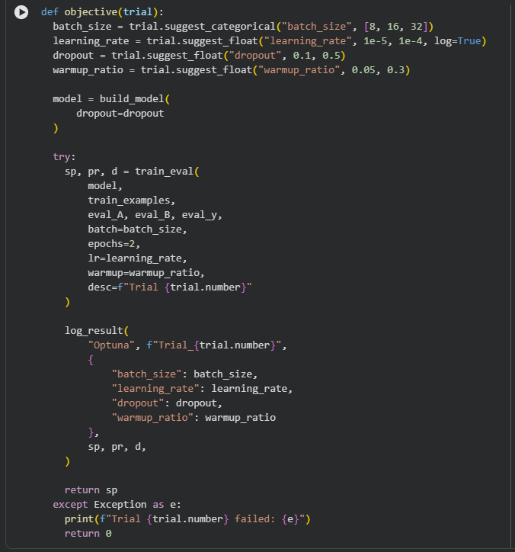
Figure 8. Optuna objective function for hyperparameter tuning
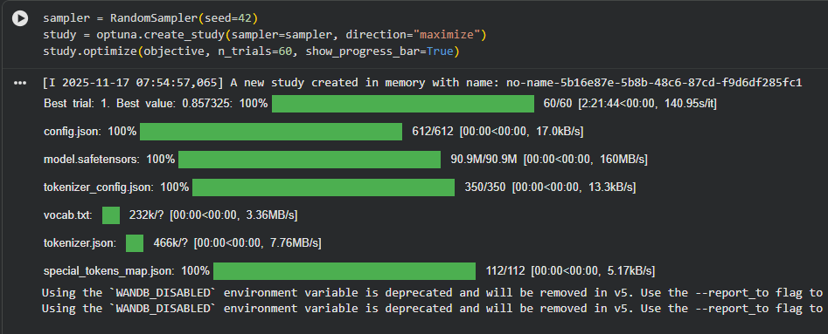Figure 9. Optuna study optimization over 60 trials

F. Final Modeling and Saving
After determining the best hyperparameters, the model was re-built using the best dropout rate, then trained again with the batch size, learning rate, warmup ratio, and number of epochs from the selected hyperparameter configurations. This training did however again follow the same train_eval procedure, but this time it was the final training step of the model - while the previous training iterations were trials of hyperparameter selection.
After the training was finished, the model weights and configuration were saved using the save_pretrained method, with the directory name being "MiniLM-L6-SciSim-SciTLDR." A results table containing a summary of all trials was created and exported as a .csv file for record-keeping, including a member identifier, experiment label, hyperparameters, Spearman and Pearson correlation, and length of time for training in minutes.
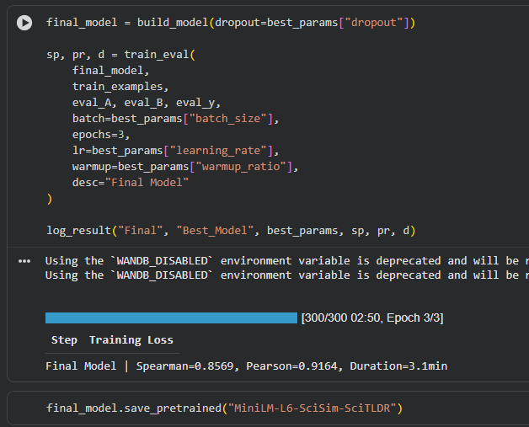Figure 10. Final model training and saving of MiniLM-L6-SciSim-SciTLDR

G. Summary Evaluation Prototype
To show the use of the fine-tuned model for assessing educational summarization, an interactive prototype was constructed in the same notebook. First, the previously saved model "MiniLM-L6-SciSim-SciTLDR" was loaded back into memory as new_model. A "helper function" called semantic_similarity(model, text1, text2) was defined, that encoded both texts, computed the cosine similarity for both texts using util.cos_sim, and scaled the similarity between a score of 0 and 1.
The prototype would allow users to upload one or more documents through the Colab file upload interface, which would place the document into a local docs directory then the user would select the one or more documents from available files displayed in an ipywidgets. Dropdown widget. Once selected, the document would be processed through the textract package which extracted the raw text from the selected documents. Subsequently, the raw text would be decoded and cleaned by collapsing excess whitespace. The cleaned text would be used as the context for summarizing.
The user was then asked to write an essay or summary showing their understanding of the content of the file they chose. The combination of the cleaned context and the user’s summary was then entered into the semantic_similarity function, which returned a similarity score. The score, along with the original texts, was printed to the console for the student to see right away how closely aligned their summary was to the original text.
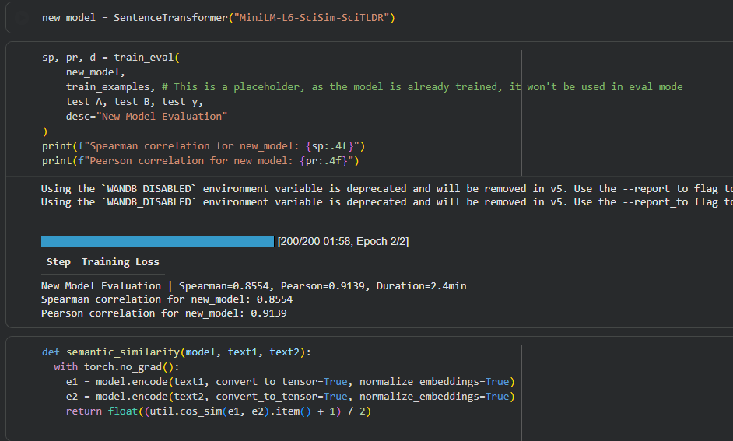
Figure 11. Evaluation of saved model and semantic_similarity function
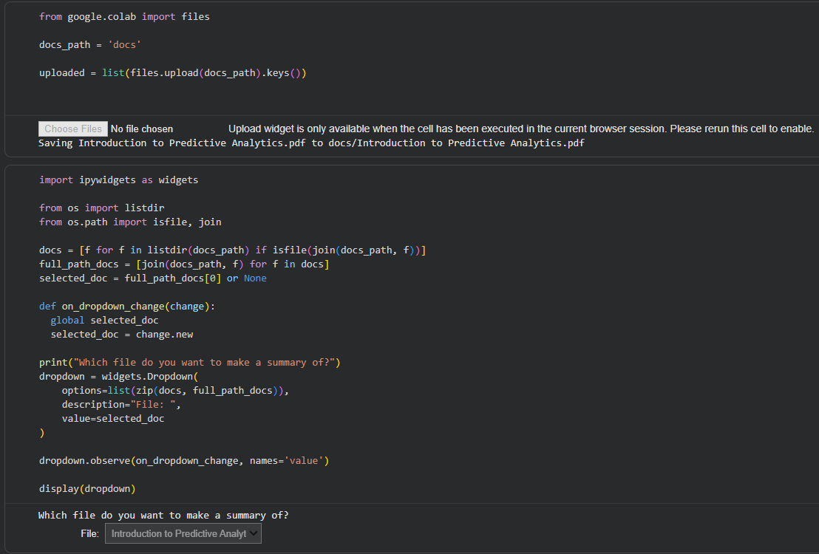Figure 12. Document upload and selection interface in Colab
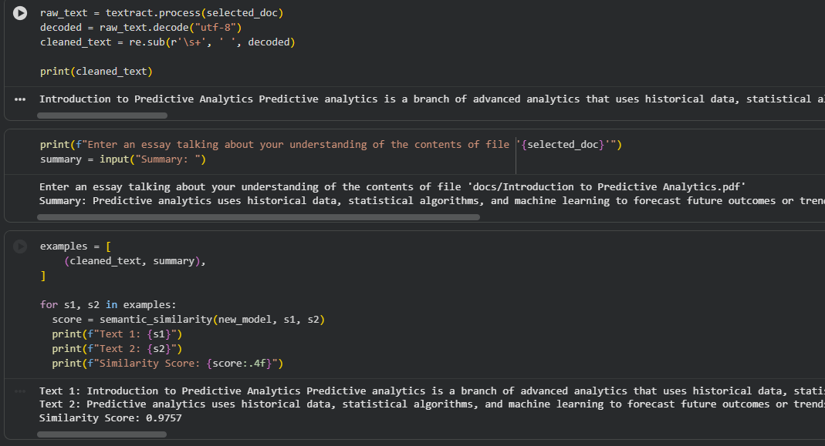
Figure 13. Context extraction, user summary input, and similarity scoring

H. Evaluation Metrics
During the experimentation phase, performance was assessed largely based on Spearman and Pearson correlation coefficients between the similarity scores the model produced and the established ground-truth labels on the test data. Spearman correlation expresses rank agreement between the predictions for similarity and the actual (indexed) similarity, which is distinct from Pearson correlation that expresses linear association. Taking these together, we assessed the degree to which the model captured semantic similarity as it aligned with human judgments.
In addition to the correlation based metrics, we also documented the training time (in minutes) for each model configuration. This allowed us to examine the trade-off between semantic (human judgment aligned) performance and cost of computation, which is important in educational contexts where such models could be used and resources might be limited. Our final analysis included both accuracy and efficiency when determining a configuration for a practical summary evaluation task in context with SDG 4.
Figure 14. Importation of Spearman and Pearson
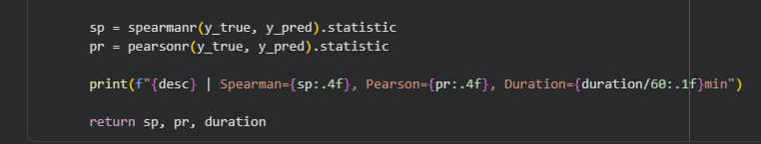Figure 15. Computation of Spearman and Pearson correlations
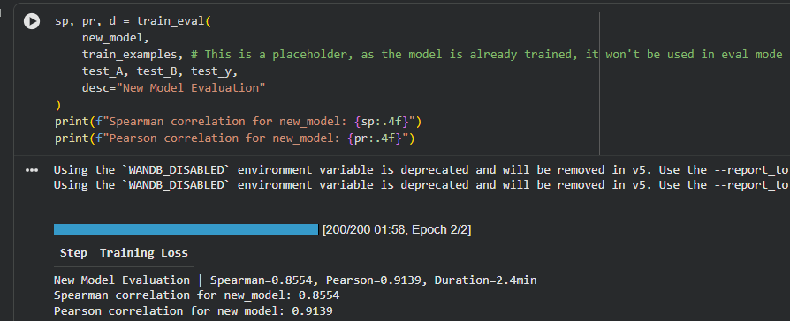Figure 16. Evaluation of the trained model on the test set

VI. Results and Discussion

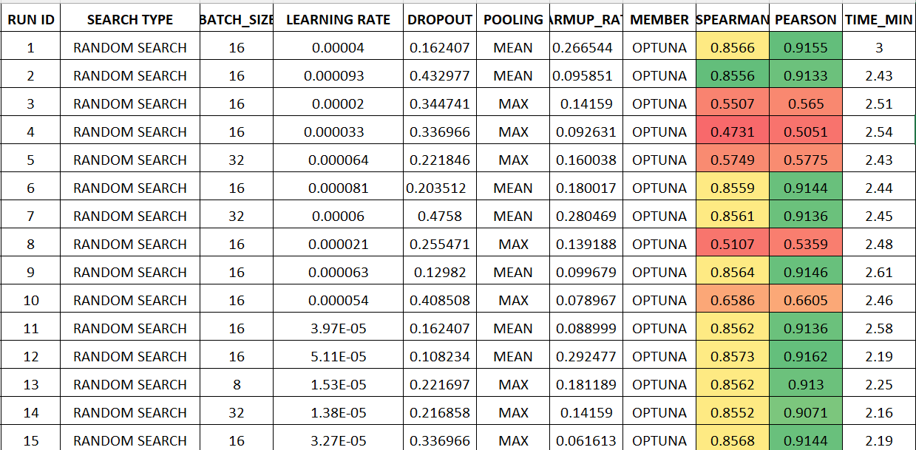
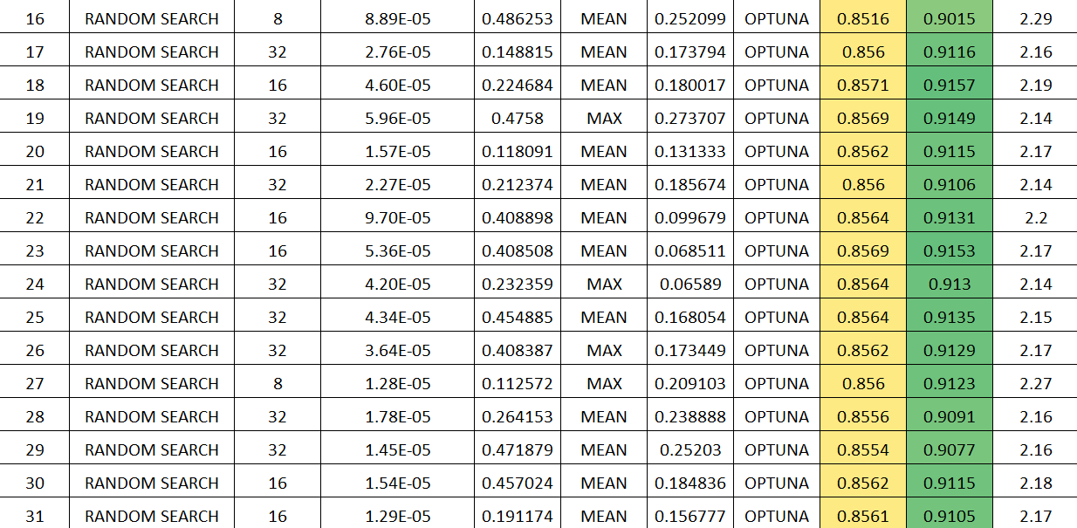
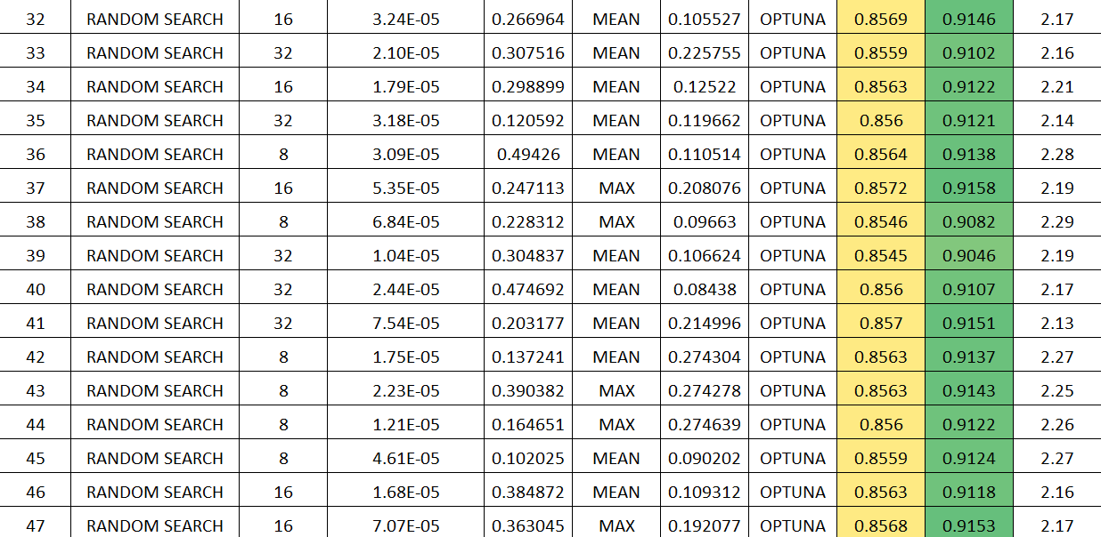
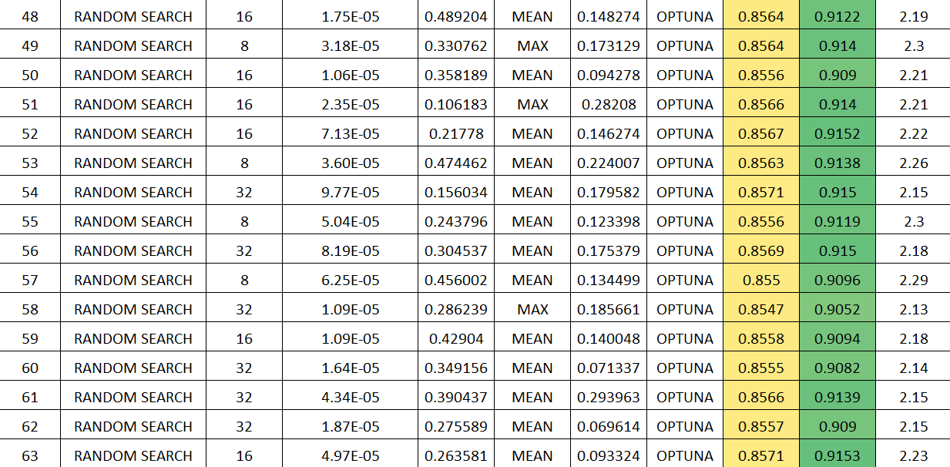
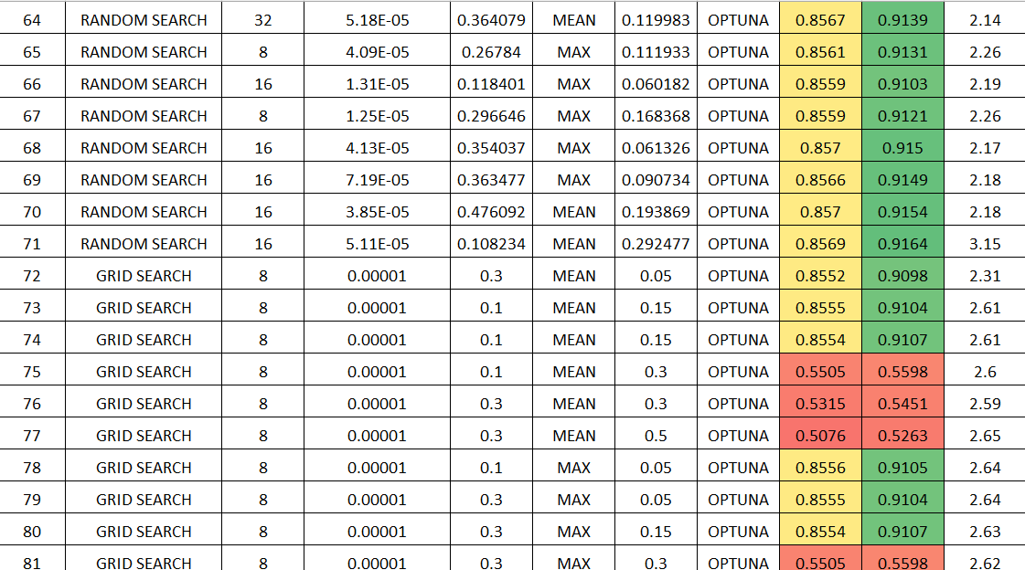
Overview of Experimentation Results (Automated Optimization
Figure 16. Experiment Logs
This experimental comparison assesses the performance of two hyperparameter optimization algorithms: Random Search and Grid Search. The algorithms were evaluated based on 81 total runs of an experiment that repeatedly tested different combinations of batch size, learning rate, dropout rate, pooling method, and warmup ratio, measuring their resulting performance with Spearman and Pearson correlation. The models resulting from Random Search showed overall superior average performance, as well as better ability to identify the best-performing hyperparameter combination compared to Grid Search. The resulting models from Random Search produced Spearman correlation values clustered around 0.856, with around 0.913 for Pearson correlations, demonstrating good stability and robustness across the hyperparameter space. On the other hand, the models from Grid Search tended to explore poor configurations even for individual runs, including a significant number of runs exploring high dropout regions, which produced Spearman scores collapsed to 0.53, indicating the rigid and inefficient nature of fixed-grid hyperparameter exploration.

In all experiments, Random Search (Run 71) produced the strongest model with a Spearman correlation of 0.8569 and highest Pearson correlation of 0.9164. The working hyperparameters for this model option included a batch size of 16, a moderate learning rate of (5.11×10⁻⁵), a low dropout of around (0.108), using MEAN pooling, and a relatively high warmup ratio (0.29). The values of the different hyperparameters generally favor a model which receives mild regularization, show modest learning behaviors, and the optimization performed is smooth due to the use of MEAN pooling. Assessment of hyperparameter trends showed that viable models consistently used effective ranges for learning rates of (1×10⁻⁵) to (6×10⁻⁵), weak dropout ratios ranging from (0.1) to (0.3), and modest warmup ratios. MEAN pooling always outperformed MAX pooling. MAX pooling consistently spat out a number of poor low performers on its own, when evaluated. There is some weak evidence of a difference within the batch size hyperparameter, but the models tended to perform most consistently and reliably when batch size is (16). The run time of the models across the different experiments held fairly constant, within a range of (2.1 - 2.3 minutes). The strongest model suggested quite a bit higher run time relative to the other models, at (3.15 minutes).

In summary, the findings indicate that, for this model and task, Random Search is preferable and produces a higher peak performance and more consistent results. The results also reveal the benefits of moderate learning rates, controlled dropout, and MEAN pooling in obtaining strong correlation metrics. This analysis provides a clear view of the hyperparameter landscape and can justify final selection of the best model configuration for downstream evaluation.

Overview of Experimentation Results(Manual Finetuning)
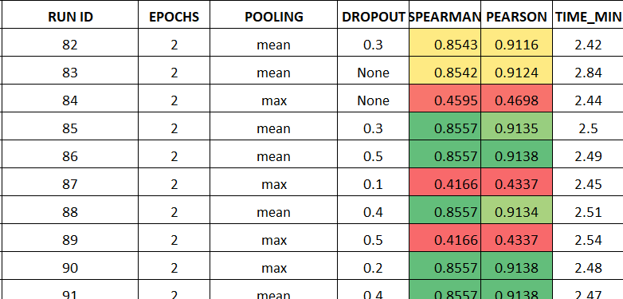
Figure 17. Architechture Parameters experiment logs

The results from Runs 82–91 examine the impact of pooling strategy and dropout rate on model performance while keeping all other training settings constant. The experiments show a consistent and pronounced difference between MEAN and MAX pooling. Models using MEAN pooling (Runs 82, 83, 85, 86, 88, 90, and 91) achieve strong and stable results, with Spearman correlations between 0.854 and 0.857 and Pearson correlations above 0.911. These high-performing runs also demonstrate robustness to dropout variation, showing little change in performance across dropout levels ranging from 0.0 to 0.4. In contrast, models using MAX pooling (Runs 84, 87, and 89) exhibit severe performance degradation, with Spearman correlations collapsing to the 0.416–0.459 range, regardless of dropout setting. This consistent failure suggests that MAX pooling disrupts the model’s ability to learn stable and informative representations, likely due to its reliance on sharper, less consistent feature activations. Runtime across all experiments remains stable, typically between 2.4 and 2.85 minutes, indicating that pooling and dropout choices affect accuracy but not computational cost. Overall, these results strongly confirm that MEAN pooling is the superior choice for this task, providing both stability and high predictive performance.

Training Configuration
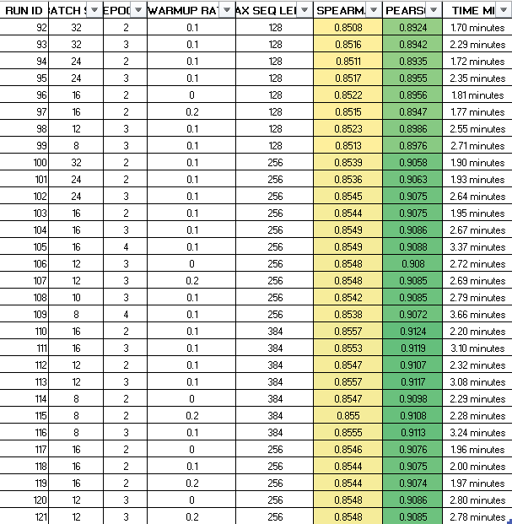
Figure 19. Training Configuration Parameters experiment logs

The results of Runs 92–121 analyze the interaction between batch size, warmup ratio, max sequence length, and epoch count while holding the pooling method constant. As expected, model performance remains quite uniform across these configurations, with Spearman correlations consistently clustered in a narrow band from approximately 0.850–0.856, and Pearson correlations ranging from about 0.892 to 0.910. There is only minor performance change from specifying a maximum sequence length of either 256 or 384 rather than 128, like the model does benefit merely slightly from more context, but is not considerably reliant on very long sequences. Likewise, batch sizes ranging from 12 to 32, show also negligible difference in performance, where this gradient noise introduced by smaller batch sizes does not significantly impact model performance. Warmup ratios of 0.1 and 0.2 seem to behave similarly suggesting the optimization procedure is not too sensitive to moderate shifts in warmup ratios. Runtime varied the most, from approximately 1.7 minutes and upward to 3.9 minutes, where longer sequence lengths and more epochs, as expected, took the longest to run. All in all this experimentation demonstrates consistent model robustness across a variety of hyperparameter choices, such that no single hyperparameter has created a significant shift in performance.

D. Optimization Parameters

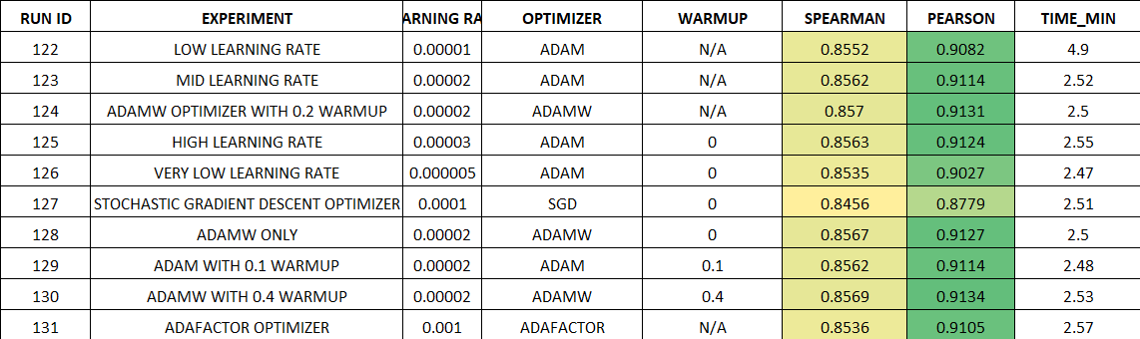

Figure 20. Optimization Parameters experiment logs

The findings from Runs 122–131 provide information on the effects of varying learning rates, optimizers, and warmup strategies on performance. Overall, the model is quite stable for most of the Adam (or AdamW) configurations, with Spearman scores remaining in the narrow band of 0.853–0.857 and the Pearson correlations remaining from about 0.908 to 0.913. Moderate learning rates around 2×10⁻⁵ reliably produce the best results, while very low learning rates (e.g., 5×10⁻⁶) marginally reduced performance due to under-training the model. AdamW performs slightly better than Adam, particularly with warmup ratios in the available range of 0.1 to 0.4 as seen in Runs 124, 128, and 130. The performance gains with higher warmup, (e.g., 0.4) values were small, but a measureable improvement occurred in both correlation metrics. In comparison, the alternative optimizers (SGD and Adafactor) produced a noticeably worse performance, with SGD having the least performance because of its (SGD) inferior adaptive properties. Runtime remains similar across models, about 2.5 minutes, though the lowest-learning-rate model (Run 122) took significantly longer to complete because of lower convergence speed.

Overall, the complete set of experiments provide strong evidence that the model is robust over a wide range of hyperparameters, and it consistently benefits from a certain set of hyperparameters that encourage stability and performance. Regardless of pooling strategy, learning rate, warmup schedule, sequence length, dropout rate, or optimizer, the strongest performing models have a number of characteristics in common, including MEAN pooling, adaptive optimizers like Adam or AdamW, moderate learning rates in the range of 1×10⁻⁵ to 6×10⁻⁵, low to moderate levels of dropout, and modest warmup ratios. These hyperparameters consistently produced Spearman correlations near 0.855-0.857 and Pearson correlations above 0.910, reflecting both high possible performance and stable training dynamics. After conducting a variety of experiments with MAX pooling, much lower learning rates, or non-adaptive optimizers (e.g., SGD), it became apparent that the model is sensitive to the choices of hyperparameters that bias representational smoothness or adaptive learning rate scaling. Additional run time evaluations indicated that the hyperparameter choices maximizing performance do not significantly financially impact rearing costs, illustrating that reasonable and effective hyperparameters can be achieved in terms of model performance. The overall findings illustrate a clear signal in a coherent manner. The model performs within the reasonable range of hyperparameters consistent with training under balanced, moderately regularizing conditions, maximizes efficiency, and optimizes for rich contextual averaging through stability for the apparatus to select final hyperparameters.

Problems Encountered
While working on this project, several obstacles arose related to both workflow efficiency and experiment consistency. The first major challenge was finding an appropriate dataset that fit the goals of the project. Many publicly available datasets were either too small, poorly annotated, or mismatched with the type of semantic or contextual modeling required. A significant amount of time was spent on determining the quality of datasets and evaluating several different datasets to see whether there was enough diversity to make the experiment relevant. The initial experiment was additionally delayed and was an added preprocessing step in the overall process to ensure that the final dataset was measured to be adequate for both training and testing.

A second primary challenge was the computational limitations of Google Colab, especially concerning the varying types and limited availability of GPU resources. Generally, models took 2–4 hours per training run, slowing down the experimental pace and making hyperparameter optimization more challenging and time-consuming. At times, the GPU memory or a session would be terminated unexpectedly and result in Colab running out of memory, causing a complete restart of the training run. These interruptions led to increased training times and reduced reproducibility, as the type of GPU and its availability changed between runs. Altogether, these computational constraints placed practical limitations on the speed of model iteration, required thoughtful planning that considered the budget for compute, and limited the efficiency of the total analytical time.

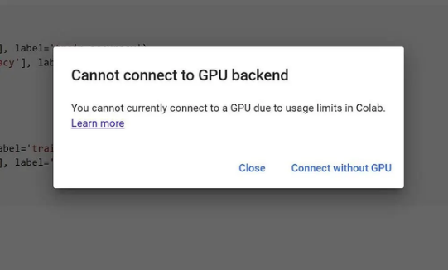
Figure 21. Warning message: Can’t Use GPU

VII. Conclusion
This project designed and tested an AI - powered summary scoring system based on a fine-tuned transformer language model for semantic similarity, which evaluates how similar a student's summary is to the underlying academic sources. The training was based on the SciTLDR dataset, and an external labeled sentence-pair dataset for testing. The objective was to systematically evaluate the effect of a number of hyperparameters on model stability and predictive accuracy including learning rate, optimizer, scheduler, batch size, epochs, gradient accumulation steps, pooling approach, dropout rate, sequence length. Automated hyperparameter optimization via Optuna was conducted, followed by manual tuning for the best performing hyperparameters. The best-performing model produced Spearman correlations around 0.8569, and Pearson correlations around 0.9164 between model predictions and human judgments of semantic similarity.

Across studies, several persistent trends were noted. Random Search consistently produced better results than Grid Search by more effectively locating higher-performing regions of hyperparameter space and avoiding many of the issues associated with fixed-grid exploration of lower-performance configurations. MEAN pooling was universally better than MAX pooling, with stable semantic representations even with varying dropout rates while MAX pooling consistently degraded some performance to collapse. The model was also resilient to small changes in batch size, warmup ratio, and sequence length, as long as the learning rates remained in a moderate range (approximately 1×10⁻⁵ to 6×10⁻⁵) and with a low-to-moderate dropout. These conclusions provide a clearer picture of the hyperparameter landscape for MiniLM-based semantic similarity on this task, and offer real world advice for future implementations in educational contexts.

Besides quantitative results, the project successfully integrated the fine-tuned model into a functional summary evaluation prototype in Google Colab. The prototype enables users to upload academic documents, automatically extract and clean the context, add their own written summaries, and receive an immediate similarity score for how closely their summary captured that content. This process supports active learning and formative assessment by prompting students to produce their own summaries, and then reflect on feedback based on semantic understanding, rather than surface-level features. In this manner, the framework embodies Sustainable Development Goal (SDG) 4 by showing how AI can help facilitate more accessible, timely, and equitable feedback about student understanding.

There are limitations or drawbacks to consider. SciTLDR and the small external eval set means that the majority of the model was trained on scientific text rather than real student writing in various subjects/disciplines. Additionally, because of computing restrictions on Google Colab, such as variable GPU availability and session dropouts, it limited the total number of experiments we could conduct and the model size and training durations in a practical way. Finally, the evaluation is primarily technical—while we have done some evaluation with genuine students and instructors, a full user study was out of scope for the project, and the effectiveness of the feedback in educational outcomes has not yet been validly demonstrated.

Future research should plan to expand the dataset to include summaries written by students from actual courses, run controlled user studies to evaluate learning gains and usability, and convert the prototype to a stable deployment system or learning management system (LMS). Further research might address richer types of feedback (e.g., highlighting concepts missing from summaries or suggesting sections from the course material that students could revisit), investigation of multilingual support, and investigate fairness across student groups. Even with these limitations, our project offers strong evidence that a well-tuned BERT-based semantic similarity model can be a reliable core of summary evaluation tools, providing a promising way towards scalable, AI-assisted formative assessment in higher education.

IX. References

- M. Brown and J. Adler, “Minds on fire: Open education, the long tail, and learning 2.0,” Educause Review, vol. 43, no. 1, pp. 16–32, 2008.
- J. Sweller, “Cognitive load during problem solving: Effects on learning,” Cognitive Science, vol. 12, no. 2, pp. 257–285, 1988.
- S. Bird, E. Klein, and E. Loper, Natural Language Processing with Python. O’Reilly Media, 2009.
- J. Devlin, M. Chang, K. Lee, and K. Toutanova, “BERT: Pre-training of deep bidirectional transformers for language understanding,” Proc. NAACL-HLT, 2019.
- C. Raffel, N. Shazeer, A. Roberts, K. Lee, S. Narang, M. Matena, Y. Zhou, W. Li, and P. J. Liu, “Exploring the limits of transfer learning with a unified text-to-text transformer,” Journal of Machine Learning Research, vol. 21, pp. 1–67, 2020.
- R. Hadiyanto and M. Ismail, “Educational applications of text summarization using Transformer models,” International Journal of Emerging Technologies in Learning, vol. 17, no. 10, pp. 32–44, 2022.
- N. Reimers and I. Gurevych, “Sentence-BERT: Sentence embeddings using Siamese BERT networks,” Proc. EMNLP, 2019.
- United Nations, “Sustainable Development Goal 4: Quality Education,” UN SDG Portal, 2024. [Online]. Available: https://sdgs.un.org/goals/goal4
- T. Luckin, W. Holmes, M. Griffiths, and L. Forcier, “Artificial intelligence in education: Promises and implications for teaching and learning,” UNESCO Education Sector, Paris, 2016.
- A. Raza, M. Shabbir, and T. Hussain, “AI-based summarization in academia: A review of methods and challenges,” IEEE Access, vol. 9, pp. 156214–156229, 2021.
- J. Dunlosky, K. Rawson, E. Marsh, M. Nathan, and D. Willingham, “Improving students’ learning with effective learning techniques,” Psychological Science in the Public Interest, vol. 14, no. 1, pp. 4–58, 2013.
- K. Dr., “Natural Language Processing and its Use in Education,” International Journal of Advanced Computer Science and Applications (IJACSA), vol. 5, no. 12, pp. 1–5, 2014, doi: 10.14569/IJACSA.2014.051210.
- S. Abdel-Salam and A. Rafea, “Performance Study on Extractive Text Summarization Using BERT Models,” Information, vol. 13, no. 2, Art. no. 67, Jan. 2022. doi: 10.3390/info13020067.
- W. Deng, “The impact of AI-generated summaries on reading comprehension among college EFL learners,” Unpublished manuscript, 2025.
- M. Mosbach, M. Andriushchenko, and D. Klakow, “On the stability of fine-tuning BERT: Misconceptions, explanations, and strong baselines,” in Proc. Int. Conf. Learning Representations (ICLR), 2021.
- M. Popel and O. Bojar, “Training tips for the Transformer model,” arXiv preprint arXiv:1804.00247, 2018.
- I. Beltagy, M. Peters, and A. Cohan, “Longformer: The long-document transformer,” arXiv preprint arXiv:2004.05150, 2020.
- E. Agirre, D. Cer, M. Diab, A. Gonzalez-Agirre, and W. Guo, “SemEval-2012 Task 6: A pilot on semantic textual similarity,” in Proc. SemEval, 2012.
- N. P. Jouppi et al., “Performance analysis of Cloud TPUs and GPUs for deep learning workloads,” in Proc. ISCA, 2017, pp. 1–12.
- J. Benesty, J. Chen, Y. Huang, and I. Cohen, “Pearson correlation coefficient,” in Noise Reduction in Speech Processing. Berlin, Germany: Springer, 2009, pp. 1–4.

