Implementation of Named Entity Recognition on News Articles

Charles Aaron Sarmiento
ITE Elective IV, BSIT – 401I
Jose Rizal University
Mandaluyong City, Philippines
charlesaaron.sarmiento@my.jru.edu

Abstract— This study implements Named Entity Recognition (NER) on a small set of international news articles using the spaCy framework. Three Reuters articles were selected and manually annotated to establish a gold standard for evaluation. The NER pipeline was applied to the datasets and assessed using accuracy, precision, recall, and F1-score. Results showed that the model achieved high performance on common and well-represented entities, such as country names and political groups, but struggled with less frequent or ambiguous terms, leading to misclassifications. The second dataset demonstrated the highest performance with an F1-score of 96%, while the third dataset performed poorly due to repeated confusion between personal names and organizations. These findings highlight the strengths of pretrained NER models for structuring unstructured news text, while also emphasizing the need for domain adaptation and fine-tuning to improve performance in diverse contexts.
Keywords— Named Entity Recognition, spaCy, Natural Language Processing, News Articles, Information Extraction

Introduction
Named Entity Recognition (NER) is one of the core tasks involved in natural language processing (NLP). It involves scanning text data to identify and classify named entities. This may include people, organizations, locations, and dates. These extracted entities, serving as structured data derived from unstructured text data, serve a crucial role in various applications like information retrieval, question answering, and machine translation [1]. With the NER process having become one of the foundational steps in information extraction, this has allowed downstream systems making use of said process to transform raw text into meaningful, and analyzable data.
Existing studies on NER has found that the process has seen continuous evolution, from the early days of rule-based systems, which was built on handcrafted rules, lexicons, orthographic features, and ontologies, to accurate systems making use of deep neural networks (NN) [2]. These advancements have made NER more accurate across various domains, including news, legal, and biomedical corpora. Despite this, challenges remain, particularly in handling low-resource languages, adapting to specific, more niche, domains, and emerging entities, making NER an area that is being continually studied.
The study aims to implement NER, processing a small set of raw text document within the domain of news and journalism. By utilizing NER in the domain of news, the process can encounter various types of entities that it can possibly identify, allowing for an easier implementation of knowledge bases, event tracking, and information retrieval systems. This study, in particular, will look at the news body of various international articles.

Methodology

Data Curation
For this study, three articles were accessed from the online news portal Reuters. Specifically, the articles were about international news, providing the NER pipeline the opportunity to encounter entities from around the world. The following articles were used:
- Defying West, China's Xi gathers 'Axis of Upheaval' at military parade [3].
- All NATO members hit old spending target, only three meet new goal [4].
- Drought leaves UK beef farmers scrambling to feed hungry herds [5].

Manual Data Annotation
Before manually annotating the text data from the articles, a list had to be established of what entities would need to be identified in a text dataset. This was done with the spaCy framework’s list of entity labels for its NER operation. The following types of entities was derived from such:
- CARDINAL - Numerals that do not fall under another type
- DATE - Absolute or relative dates or periods
- EVENT - Named hurricanes, battles, wars, sports events, etc.
- FAC - Buildings, airports, highways, bridges, etc.
- GPE - Countries, cities, states
- LANGUAGE - Any named language
- LAW - Named documents made into laws.
- LOC - Non-GPE locations, mountain ranges, bodies of water
- MONEY - Monetary values, including unit
- NORP - Nationalities or religious or political groups
- ORDINAL - "first", "second", etc.
- ORG - Companies, agencies, institutions, etc.
- PERCENT - Percentage, including "%"
- PERSON - People, including fictional
- PRODUCT - Objects, vehicles, foods, etc. (not services)
- QUANTITY - Measurements, as of weight or distance
- TIME - Times smaller than a day
- WORK_OF_ART - Titles of books, songs, etc.

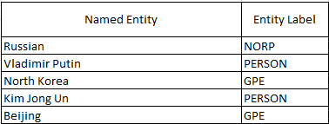
- Snippet of Manual Annotation of Text Dataset.
With the list of entities established, the articles were manually observed and read through to look for entities that should be identified. This was done in the Excel spreadsheet program, showing the word/s, as well as what type of entity it is. This will serve as the “gold standard” and will be used to compare and evaluate the results of the NER model from the spaCy framework.

Automated Entity Recognition
Once the ground truth was defined for the text datasets, the articles were fed to the spaCy framework’s NER pipeline. The pipeline includes processes like a tokenizer, a token-to-vector model, a part-of-speech tagger, a dependency parser, a token attribute mapping and rule-based exception assigner, and a lemmatizer, before the processed text is fed to the NER process.
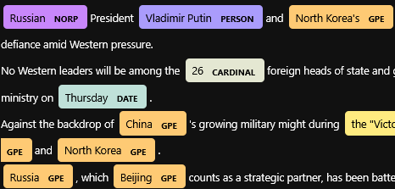
- Snippet of Visualization of NER Entity Labels.
Once the process is done, the result of the identified entities is given. This was given in a Python list, containing the entity, its type label, as well as a brief explanation on the derived type label. To provide a better visualization, the spaCy framework’s displacy NER visualizer was used to display the text dataset, with the entities highlighted with its derived type. The derived types were also entered in the spreadsheet alongside the “gold standard” types.

Performance Analysis and Accuracy Assessment
To evaluate the performance of the NER process, several metrics were calculated. These are:

Accuracy
Accuracy measures the ratio between the total correctly classified words and the total words in the dataset. While it may not seem that it provides insights on how accurate the NER process is, the statistic this metric gives can be used to provide insights on how much of the dataset was made up of entities. Equation (1) is how the accuracy for this process was calculated.
Accuracy = Correct Entities / Total Words (1)

Precision
Precision is the fraction of predicted entities that are actually correct. This can give insights as to how “right” the model was in properly identifying the type of entity in the dataset. Equation (2) is how precision is derived for this process.
Precision = Correct Entities / Total Predicted Entities (2)

Recall
Recall is the fraction of actual entities that the model successfully identified. This can provide an idea on how likely the NER process is able to actually identify the entities in the dataset. Low performance on this metric may indicate that the process is missing some crucial entities. Equation (3) is how recall is derived.
Recall = Correct Entities / Total Actual Entities (3)

F1-score
F1-score is the relationship between the precision and recall metric. It balances both metrics into a single performance measure, where a high F1-score could indicate that both precision and recall are high. A low F1-score could mean that either of the metrics are low and it could be good looking at said metric deeper to address the model’s performance. This metric is derived from the harmonic mean of both metric, of which an example can be found in (4).
F1-Score = 2 * (Precision * Recall) / (Precision + Recall) (4)

Results

Accuracy
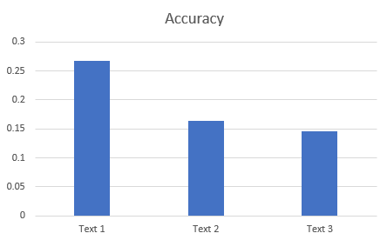
- Accuracy Score of each Text Dataset.
From this accuracy score, the study has observed that only around 25% of the text datasets contain identifiable entities. The first text dataset [3] has significantly more entities due to the fact that the article referenced countries and names of presidents a significant amount of time.

Precision
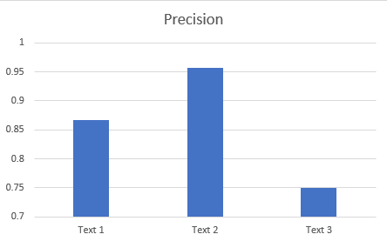
- Precision Score of each Text Dataset.
The precision score of each text dataset shows how many correct predictions were made. The second text dataset had the highest precision, around 95%, and it can be assumed by the fact that most of the entities in the text are common and is easily identifiable in the English dataset. Meanwhile, the first dataset had trouble correctly labelling some countries and political parties. Meanwhile, the third dataset had a severely degraded precision score, and it can be attributed to the fact that the NER process had consistently incorrectly labelled a person’s name as an organization.

Recall
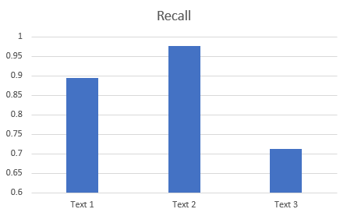
- Recall Score of each Text Dataset.
The recall score of each text dataset displays the model’s ability to correctly identify if it is actually an entity or not. The second dataset has shown near perfect recall, while the first and third dataset has missed a couple of entities, which could be explained by it being less common or in a different language.

F1-Score
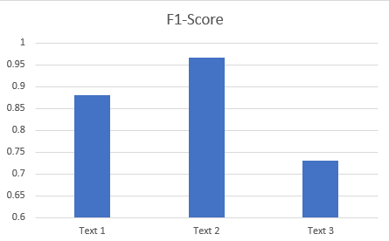
- F1-Score of each Text Dataset.
The F1-Score of each text dataset is a general indicator on how “good” the NER process is in identifying entities in the dataset. The second dataset, with an F1-score of around 96% proved to be the one that has allowed the process to the most accurate in identifying and labelling entities. The third dataset’s low recall and precision scores has proven that it contained entities that is confusing to label, or is outright not identifiable for the NER process.

Discussion
The experiment results show how spaCy's NER pipeline performance can change based on input text characteristics. While the second dataset with more conventional and readable entities like country names and political parties had close-to-perfect precision, recall, and F1-scores reflecting robust performance on English's well-represented entities, the first dataset struggled to accurately tag some political parties and country mentions which reflects model weaknesses when dealing with less frequently occurring or confusing terms. Performance for the third dataset deteriorated across all metrics with repeated model confusion of personal names with organizations, reflecting continued challenge for model based on contextual information as well as linguistic variation. These results indicate pretrained NER tools are robust for strong performance in structured and everyday applications but vary in applicability when dealing with variable international texts, mostly when entities are not within model's dominant training set.

Conclusion
This research applied Named Entity Recognition (NER) on a sample set of foreign news articles based on the spaCy system and tested its performance based on accuracy, precision, recall, and F1-score. The results indicate that the model is able to perform at a high level when dealing with common and generally represented entities but is unable to handle less common or ambiguous terms, which results in classifications in error. These results highlight a need for domain adaptation as well as further fine-tuning when using NER in diverse datasets. Even so, the research proves practical applicability in using NER for organizing unstructured news text for tasks such as knowledge base building and tracking events. Future applications might involve growing the set, implementing the training in a domain-specific manner, or trying transformer-based applications for enhanced accuracy in entity detection in a variety of settings.

References
- J. Li, A. Sun, J. Han, and C. Li, “A survey on deep learning for named entity recognition,” IEEE Transactions on Knowledge and Data Engineering, vol. 34, no. 1, pp. 50–70, Jan. 2022, doi: 10.1109/TKDE.2020.2981314.
- V. Yadav and S. Bethard, “A survey on recent advances in named entity recognition from deep learning models,” in Proc. 27th Int. Conf. Comput. Linguistics (COLING), 2018, pp. 2145–2158.
- J. Cash and R. Woo, “Putin, Kim Jong Un to attend Chinese parade in show of ...,” Reuters, https://www.reuters.com/business/aerospace-defense/putin-kim-jong-un-attend-chinese-parade-show-defiance-west-2025-08-28 (accessed Aug. 28, 2025).
- “All NATO members hit old spending target, only three meet new goal | reuters,” Reuters, https://www.reuters.com/business/aerospace-defense/all-nato-members-hit-old-spending-target-only-three-meet-new-goal-2025-08-27/ (accessed Aug. 28, 2025).
- J. Davey, “Drought leaves UK beef farmers scrambling to feed hungry herds | reuters,” Reuters, https://www.reuters.com/sustainability/climate-energy/drought-leaves-uk-beef-farmers-scrambling-feed-hungry-herds-2025-08-28/ (accessed Aug. 28, 2025).

