Implementation and Evaluation of Natural Language Processing Models

Charles Aaron Sarmiento
ITE Elective IV – BSIT 401
Jose Rizal University
Mandaluyong City, Philippines
charlesaaron.sarmiento@my.jru.edu

Abstract—The present research documents the implementation and evaluation of four basic Natural Language Processing (NLP) tasks: text classification, part-of-speech (POS) tagging, sentiment analysis, and text summarization. Employing the spaCy library, different models were developed and tested using typical datasets and evaluated using predefined performance metrics. The experiments showed strong performance in text classification and POS tagging, while sentiment analysis showed mediocre performance, explaining it by dataset limitations and class imbalance. The text summarization system showed high recall but lower precision and hence outlined challenges towards generating concise outputs. Overall, the outcomes identify dataset quality, class distribution, and task complexity as strong determiners of NLP model effectiveness while highlighting evaluation metrics like accuracy, precision, recall, F1-score, and ROUGE as crucial towards comprehensive performance analysis.
Keywords— natural language processing, text classification, part-of-speech tagging, sentiment analysis, text summarization, evaluation metrics, rouge, spacy

Introduction
Natural Language Processing (NLP) is a continuously-evolving field in the area of artificial intelligence. The core focus of NLP is the process of designing analytical models that has the ability to process, comprehend, and generate human text, extracting meaning from seemingly unstructured data points and be able to generate useful insights.
Key applications of NLP are text classification, and sentiment analysis which can be seen as an extension of text classification, part-of-speech (POS) tagging, and text summarization. Text classification involves analyzing the composition of textual data and providing labels that can categorize the given text, which is often used to aid in information retrieval and organization. Meanwhile, part-of-speech (POS) tagging involves looking at each token in the text and providing them with the appropriate grammatical tag, like nouns, verbs, etc. POS tagging is often used to aid in more sophisticated linguistic processing, giving more information that the model can work with. Sentiment analysis, an extension to the capabilities of text classification, is the process of analyzing text to acquire an overall sentiment. This is commonly used in customer satisfaction and trend analysis, letting business understand how the masses feel about a certain product or topic. Lastly, text summarization aims to condense big blocks of text into an easier to understand length while still retaining the original idea of the text.
In this activity, all four of these NLP tasks will be implemented and their performance will be analyzed. This will involve the creation of models and pipelines that are capable of text classification, POS tagging, sentiment analysis, and text summarization. After their creation, each model will be evaluated and scored with the appropriate metrics. Text summarization will be scored using ROUGE, which measures the overlap between two text, while the rest of the processes will be scored on their accuracy, precision, recall, and F1-score.

Methodology
For this study, the implementation of each NLP process is done with the features included in the spaCy Python library. The library provides a system of establishing text processing pipelines and processing components that can turn raw text data into useful text representation and even basic insights.

Text Classification
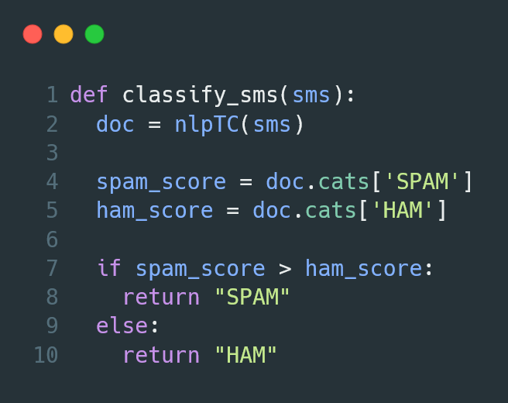
- Snippet of SMS spam classification function using spaCy’s pipeline
For text classification, the TextCategorizer pipeline component of spaCy is used. This component analyzes the provided text and outputs annotations on the probability that the given text is of the given label. The process is implemented on a subset of the SMS Spam Collection dataset made by Almeida and Hidalgo[1].
This process involves creating a blank language pipeline and adding the TextCategorizer component it. The labels ‘SPAM’ and ‘HAM’ were indicated to the component. The dataset was split 80% training data, which will be used to update the model, and 20% testing data, which will be introduced to the model as unseen data and where the performance of the model will be measured from.
Once the model is trained, its performance is measured using accuracy, precision, recall, and F1-score. This done with the Scikit-learn’s classification_report function, which cleanly prints a summary of these scores when given the predicted and “gold standard” data.

Part-of-Speech Tagging
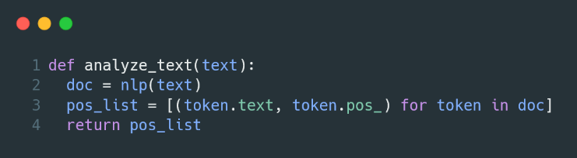
- Snippet of Part-of-Speech tagging using spaCy’s pipeline.
The part-of-speech (POS) tagging functionality is implemented with spaCy’s Tagger pipeline component, which labels tokens in the text data based on the vocabulary that was pre-trained in the pipeline. The selected pre-trained model for this implementation is the en_core_web_sm model that is provided in the spaCy library. It includes a pre-trained English language vocabulary, along with common pipeline components like a dependency parser, lemmatizer, and named entity recognition, to name a few.
The dataset used in this implementation is an entry from the English Web Treebank [2], which is used by Universal Dependencies as the gold standard corpus for English POS tagging.
The implementation is done by loading the pre-trained pipeline, which eliminates the need for any kind of training. With the model loaded, the text is processed by said pipeline, which outputs a document that includes tokens that have been POS tagged.
To measure the performance of the process, a Scikit-learn’s classification_report function is used to generate accuracy, precision, recall, and f1-score.

Sentiment Analysis
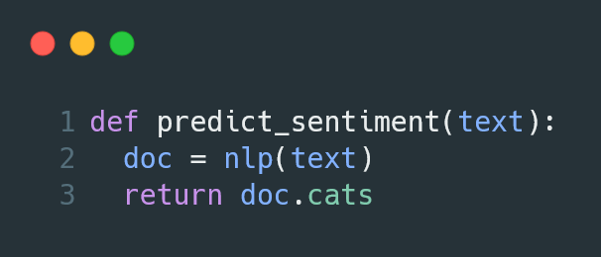
- Snippet of Sentiment Analysis using spaCy’s Text Categorizer.
The sentiment analysis is implemented with spaCy’s Text Categorizer pipeline component, where it analyzes the given text data and predicts the sentiment of it. For this implementation, the model aims to predict if a given review can be considered positive or negative.
The dataset used in this implementation is a subset of the IMDB reviews dataset made by Maas, et. al [3]. The dataset contains scraped movie reviews from the movie information and review platform IMDB. It also contains a label indicating if the given review is considered positive or negative.
Just like with the text classification process, a blank pipeline is created where the text classification component is added with the labels “POSITIVE” and “NEGATIVE.”
The metrics used for this process are the accuracy, precision, recall, and F1-scores, which is calculated and displayed with Scikit-learn’s classification_report function.

Text Summarizer
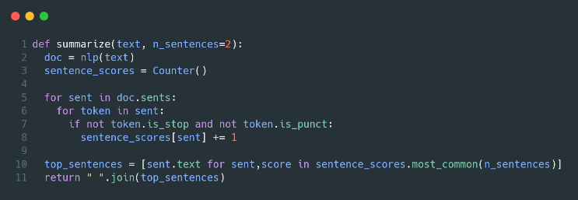
- Snipet of the Text Summarizer functionality with spaCy’s pipeline.
The text summarizer process is implemented with the help of spaCy’s tokenizer as well as its AttributeRuler pipeline component. This process is done by scoring sentences in the given text with how much important tokens are found in it. The sentences with the highest scores are the ones selected to be as that text’s summary.
The dataset used in this implementation is a single entry from the set in the study conducted by Nallapati, et. al. [4]. It consists of news articles, as well as a summary of said article.
For the implementation, a pre-trained English model pipeline is loaded. The process makes use of the AttributeRuler component to see if a certain token is not a stopword, or a punctuation. Each sentence found with tokens matching this condition has a score given to them which is based on said tokens’ frequency. The sentences with the highest scores are to be selected as part of the text’s summary.
The metric used for evaluating the performance of this process is ROUGE. Recall-Oriented Understudy for Gisting Evaluation (ROUGE) is ROUGE (Recall-Oriented Understudy for Gisting Evaluation) is a metric used to evaluate text summarization by comparing the overlap between a generated summary and human-written reference summaries. It measures recall, precision, and F1-score based on shared n-grams, longest common subsequences, or skip-bigrams.

Results

Text Classification
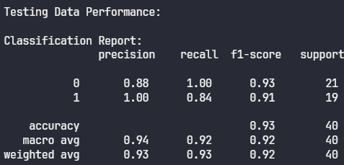
- Accuracy, Precision, Recall, and F1-Score of Text Classification.
The binary classification model achieved commendable results, posting an overall accuracy of 0.93. Class 0 demonstrated perfect recall (1.00) with slightly lower precision (0.88), indicating that while nearly every true class 0 instance was correctly identified, the model included some false positives. In contrast, class 1 showcased impeccable precision (1.00) but a lower recall (0.84), suggesting a more conservative approach in labeling positives and missing several actual cases. Both classes recorded robust F1-scores in the 0.91 to 0.93 range, while strong macro and weighted averages reaffirmed the model’s reliable performance across the dataset.

Part-of-Speech Tagging
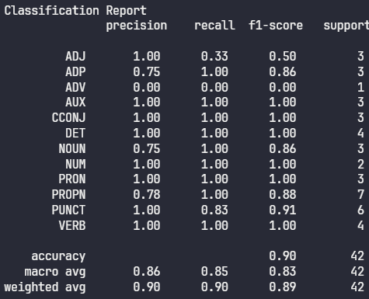
- Accuracy, Precision, Recall, and F1-Score of POS Tagging.
For part-of-speech tagging, the model reached an overall accuracy of 0.90, performing particularly well in categories such as determiners, nouns, pronouns, and verbs—all predicted with high precision and recall. Notably, performance declined for less-represented classes: adjectives and adverbs exhibited significant limitations, with recall dropping to 0.33 and 0.00, respectively, leading to markedly low F1-scores in those categories. A macro average F1-score of 0.83 pointed to this performance disparity, while the weighted average of 0.89 reflected the model’s greater competence with more frequent tags.

Sentiment Analysis
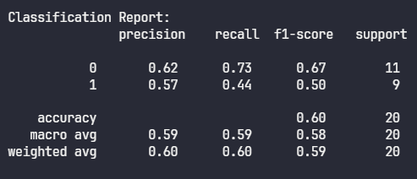
- Accuracy, Precision, Recall, and F1-Score of Sentiment Analysis.
The smaller binary classification task yielded less impressive outcomes, as evidenced by an accuracy of 0.60. Here, class 0 benefitted from a comparatively higher recall (0.73) and F1-score (0.67), whereas class 1 achieved only 0.44 in recall and 0.57 in precision. The macro and weighted averages lingered around 0.59–0.60, highlighting performance challenges and clear class imbalance within the dataset. These results indicate the need for model rebalancing or enhanced feature engineering to address these limitations.

Text Summarizer
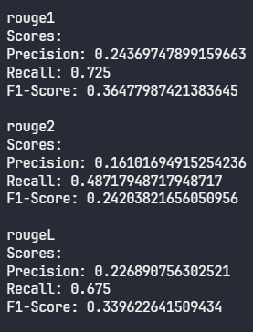
- Rouge Scoring of Sentiment Analysis.
Regarding the summarization system, ROUGE metrics illustrated a notable recall-precision gap across ROUGE-1, ROUGE-2, and ROUGE-L. For example, ROUGE-1 recall was 0.725, while corresponding precision lagged at 0.243, resulting in a moderate F1-score (0.365). The pattern remained consistent for ROUGE-2 and ROUGE-L, with recall scores substantially exceeding precision, thereby revealing that while the system succeeded in including substantial reference content, it also produced redundant or irrelevant information. Overall, the generated summaries capture a reasonable breadth of content but would benefit from greater conciseness and focus.

Discussion
The implementation of the four NLP processes yielded a diverse set of outcomes, revealing both the strengths and limitations of the models utilized. In the binary text classification task, model performance was notably strong, demonstrating an overall accuracy of 93%. This result suggests that the classifier effectively differentiated between categories, although some trade-offs between precision and recall were observed depending on the class in question.
For part-of-speech tagging, the model attained an accuracy of 90%, performing particularly well on frequently occurring tags such as nouns, determiners, pronouns, and verbs. Performance for less frequent tags, including adjectives and adverbs, was less robust. This drop-off illustrates the impact of data imbalance on the model’s capacity to generalize across a full range of grammatical categories.
A second binary classification task, conducted on a smaller dataset, led to a marked decrease in accuracy—down to 60%. This decline likely reflects the dual challenges posed by limited sample size and the difficulty of detecting underrepresented classes.
Regarding the summarization system, ROUGE scoring indicated higher recall compared to precision. This finding implies that, while the summaries retained much of the source content, they also incorporated extraneous details, resulting in outputs that were more expansive than concise.

Conclusion
These results underscore the critical influence of factors such as dataset size, distribution of classes, and overall task complexity in shaping model effectiveness. The practical exercise of implementing text classification, part-of-speech tagging, sentiment analysis, and summarization highlighted that models tend to achieve best results when trained on balanced datasets and can struggle with rare or underrepresented categories. Moreover, the tendency of summarization systems to prioritize content coverage at the expense of brevity was clarified by the evaluation metrics.
Ultimately, these findings reinforce the importance of metrics such as accuracy, precision, recall, F1-score, and ROUGE for a comprehensive assessment of NLP models. Future research may benefit from targeted strategies to improve performance on rare categories, the enhancement of feature representations, and the adoption of advanced model architectures to achieve a more optimal balance between recall and precision.

References
- T. Almeida and J. Hidalgo. "SMS Spam Collection," UCI Machine Learning Repository, 2011. [Online]. Available: https://doi.org/10.24432/C5CC84.
- Natalia Silveira, undefined., et al, "A Gold Standard Dependency Corpus for English," in Proceedings of the Ninth International Conference on Language Resources and Evaluation (LREC-2014), 2014.
- Maas, A., et al, "Learning Word Vectors for Sentiment Analysis," in Proceedings of the 49th Annual Meeting of the Association for Computational Linguistics: Human Language Technologies, 2011, pp. 142–150.
- R. Nallapati, B. Zhou, C. dos Santos, C. Gulcehre, and B. Xiang, “Abstractive text summarization using sequence-to-sequence RNNS and beyond,” Proceedings of The 20th SIGNLL Conference on Computational Natural Language Learning, 2016. doi:10.18653/v1/k16-1028

